Technical Design Document

AIMS - Apprentice Internship Management System

ADDENDUM – ADMIN WEB WIREFRAMES



# Version History

|  |  |  |
| --- | --- | --- |
| **Date** | **Author** | **Description** |
|  |  |  |
|  |  |  |
|  |  |  |
|  |  |  |

# Acronyms

|  |  |
| --- | --- |
| **Acronym** | **Definition** |
| SOW | Statement of Work |
| TDD | Technical Design Document |
| AIMS | Apprentice Internship Management System |
|  |  |
|  |  |
|  |  |

# References

1. AIMS SOW, EFC Salesforce / Tinderbox

# Table of Contents

1 Version History 2

2 Acronyms 2

3 References 2

4 Table of Contents 3

5 Introduction 4

6 Scope 5

6.1 Mobile App Features 5

6.2 Web App Features 5

7 Mobile Wireframes 6

7.1 Login 6

7.2 Register 7

7.3 Calendar 8

7.4 Daily Check In 9

7.5 Weekly Survey 10

7.6 Raise Hand / Ask Question 11

7.7 Profile 12

8 Web App Wireframes 13

9 Data Model 14

9.1 Data Model Details 14

10 Technical Architecture 15

# Introduction

This is an addendum to the AIMS TDD. It elaborates on the web wireframe design.

# Overall Flow

<insert flow here>

# Wireframes

## Timesheets List

<blurb about what this screen is>

<Use case or 2>

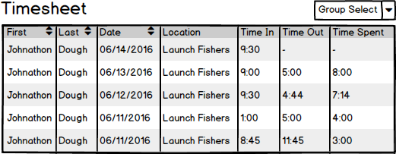

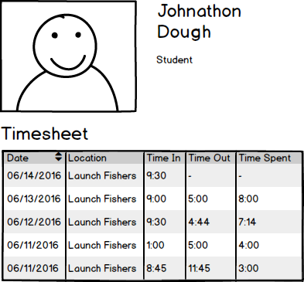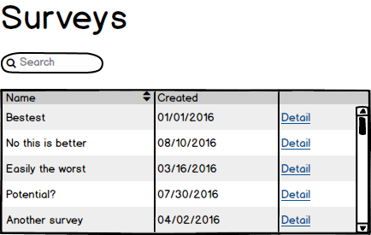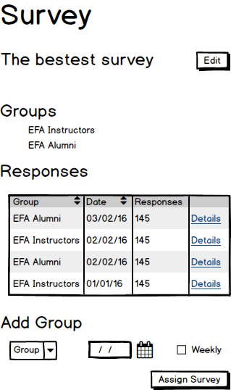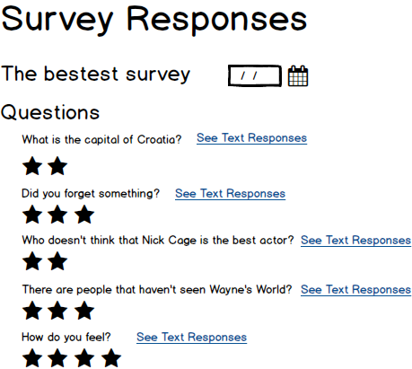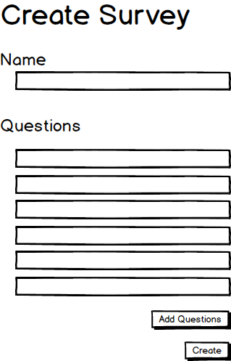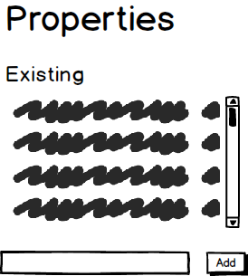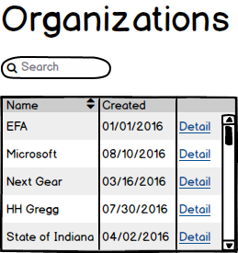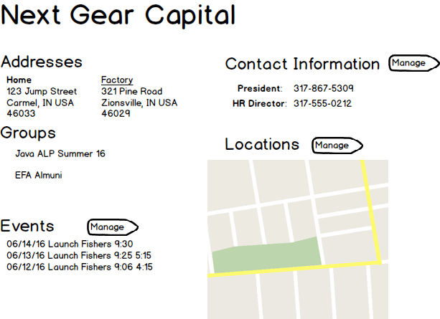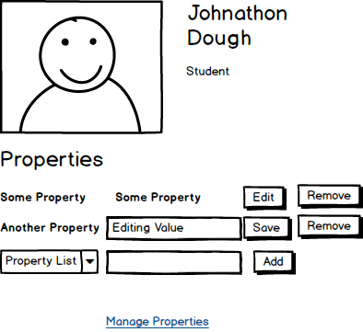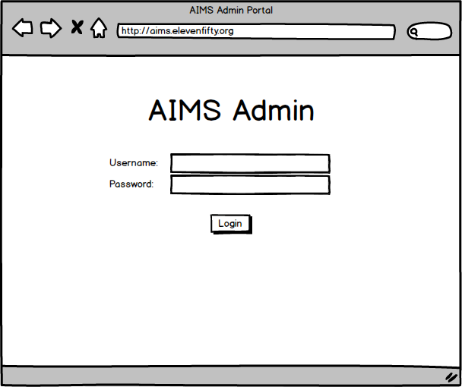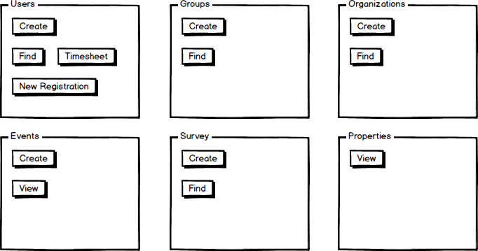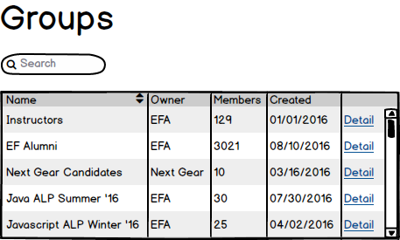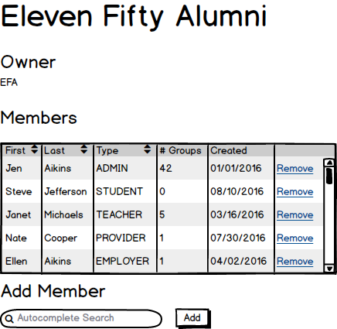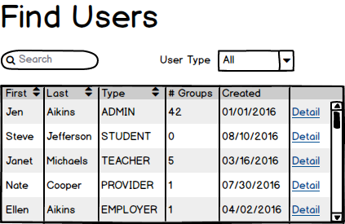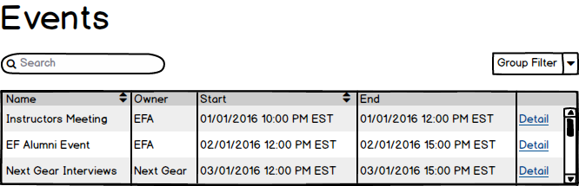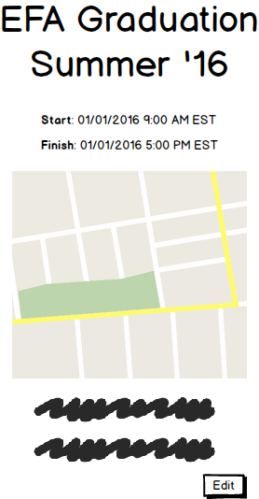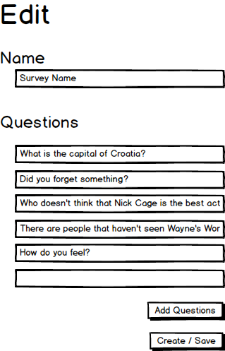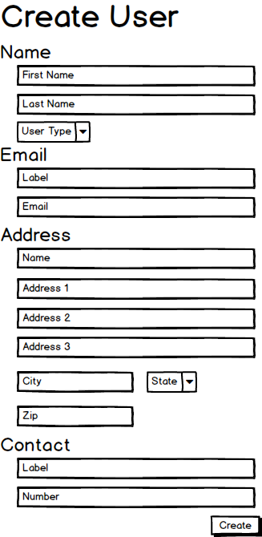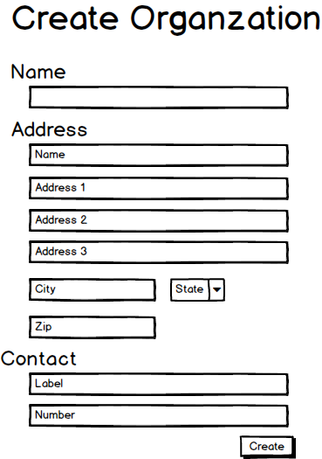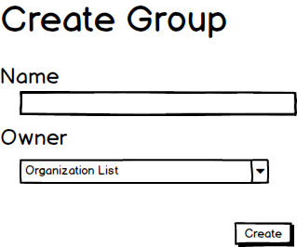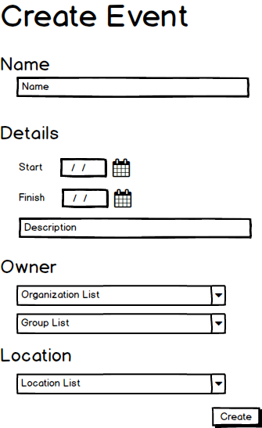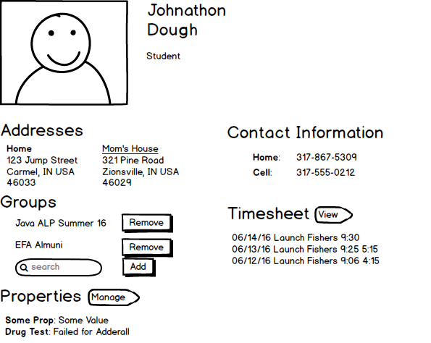

# Appendix A – Discussion Records